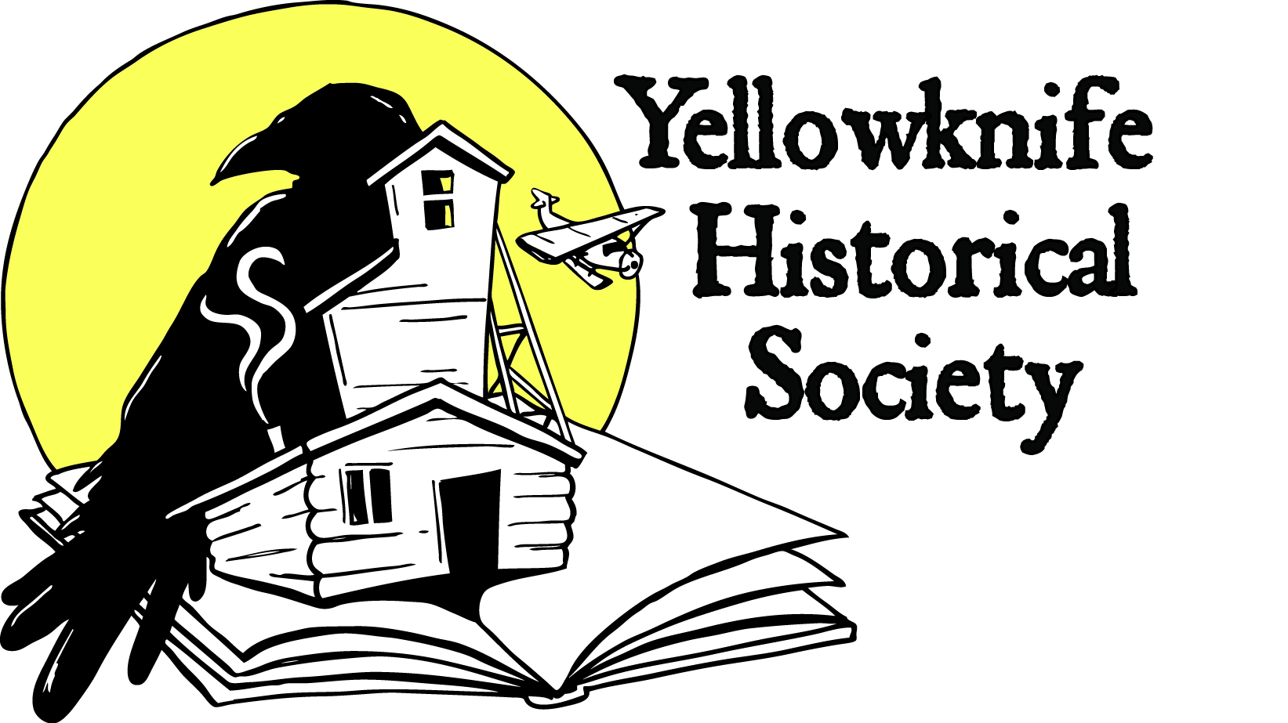 Newsletter November 2018
SOCIETY ANNUAL GENERAL MEETING
The Annual General Meeting was held on October 4, 2018 at the Baker’s Centre. An update on the museum construction was provided plus a slideshow of the work progress this summer to continue renovations to the historic Giant Mine recreation hall. Thanks to all who attended!
At a recent board meeting a new executive was chosen: Walt Humphries, president of the society since 2002, has stepped down, but will remain on the executive in an advisory role during this time of transition. Helmut Epp was named president, Ryan Silke vice-president, and David Finch secretary-treasurer.
MUSEUM CONSTRUCTION COMPLETED!
Construction is wrapping up for the season at the Giant Mine recreation hall building, the proposed museum exhibit facility. During July to November 2018, Paul Brothers Nextreme Inc. completed a $185,000 contract to remove asbestos, repair exterior walls, and install new windows, doors and siding. The results look fantastic! Eddie Paul and his crew are to be commended for a job well done.
The project was supervised by Society executive Walt Humphries, Helmut Epp, Ryan Silke and coordinator Tracey Bryant. This is a major step forward as repair of the exterior has been a significant holdup in moving forward with the museum construction. Funding for the project was provided in part by the Government of the Northwest Territories, Industry Tourism and Investment.
The next phase of renovations will require a significant investment. We are currently completing application forms for new government grants, including the Federal Government’s ‘Canadian Northern Economic Development Agency’ (CANNOR) and the GNWT’s ‘Community Tourism Infrastructure Contribution Program’ to complete all remaining construction, including: insulation, electrical, mechanical, parking lot, landscaping, fire suppression, security, and displays.
Costs are projected to run up to $1.1 million. As we may not receive this entire amount, we are canvassing local businesses to help raise any additional funds. A ‘Business Plan’ is available for download at our website that outlines the project in more detail.

COMING EVENTS – A “WHAT IF” History of Yellowknife
Presented by Ryan Silke
Historian, Yellowknife Historical Society

From rocks to riches…Yellowknife’s success has been in part thanks to the minerals beneath our feet. But what if the gold credited with kick-starting the community back in 1934 never existed? What if the city lost its bid to become capital of the NWT in 1967? What if the diamond deposits that have sustained our economy for the past twenty years were never found? This unconventional talk looks at the keystone events in Yellowknife’s history and then discusses the consequences on the community if they did not happen. Presented in support of the Yellowknife Historical Society’s community museum project at Giant Mine.
Everyone is Welcome!
7:30pm Wednesday November 21, 2018
Prince of Wales Northern Heritage Centre
Public Lecture Sponsored by Northwest Territories and Nunavut Association of Professional Engineers and Geoscientists (NAPEG).
ABOUT THE MUSEUM PROJECT
The Yellowknife Historical Society envisions the museum site at Giant Mine as a place that celebrates all aspects of Yellowknife's interesting history, from its Indigenous stories, geological setting, prospecting, the industrial activities of the gold mines, and the pioneer entrepreneurs that began the town in the 1930s. Inside we will be displaying mining and Yellowknife history and that should broaden its appeal and increase the number of visitors.
Yellowknife Historical Society
Box 1856 Yellowknife NT X1A 2P4
www.yellowknifehistory.com
info@yellowknifehistory.com

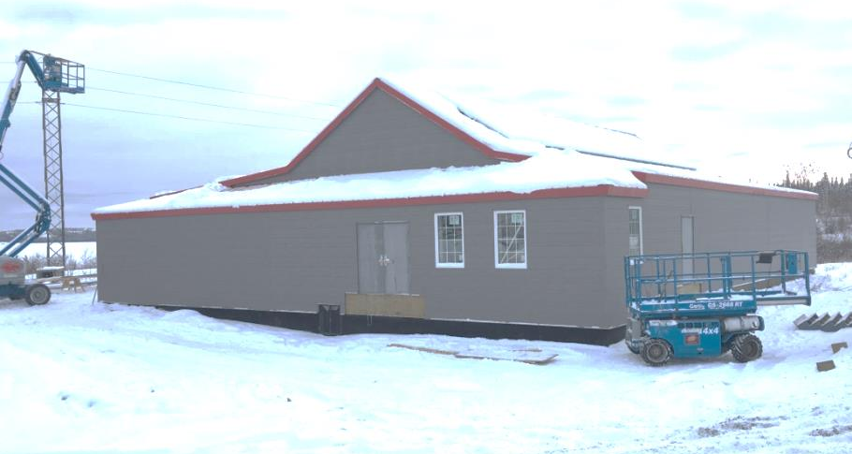
Museum building November 2018

