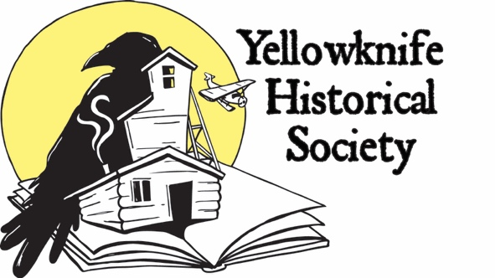 Newsletter Summer 2020

Happy spring time in Yellowknife! Welcome to the first newsletter of 2020 - here are a few updates from the Society.
BEER BARGE UPDATE
Due to the ongoing Covid-19 pandemic and the many restrictions in place, the Board regrets to announce that Beer Barge 2020 will NOT be happening this year. We are very sad that we cannot organize this wonderful Old Town party but we feel it is necessary given the uncertainty. There are many other community festivals canceling summer plans as well, including Folk on the Rocks. You can still support these events by purchasing merchandise! We have new Beer Barge merchandise for sale starting immediately: Beer steins with the famous Beer Barge logo! A limited order of acrylic 18-ounce steins have arrived, and a more robust 20-ounce glass stein are still on order.
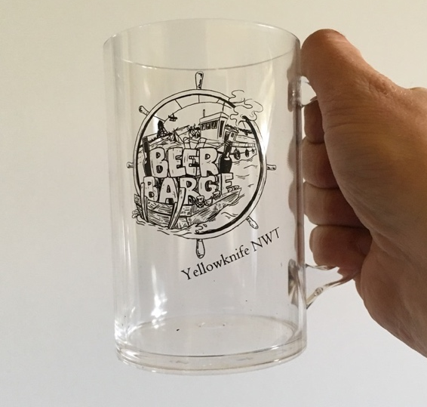
Acrylic beer stein, 18-ounces
Price - $12
Contact info@yellowknifehistory.com to place an order today. Available for pickup in Yellowknife only at this time.
GIANT MINE REMEDIATION PROJECT UPDATE
The Giant Mine Remediation Project held a Public Hearing in Yellowknife from January 20-24, 2020. Helmut Epp and Ryan Silke were representatives of the Society and presented as an intervenor in the process. We argued for our land use in the area and provided comments on borrow source locations and how we would like the open pits in the Giant Mine townsite area to be remediated. More consultation will take place on these issues; currently, all community consultation is on hold due to the pandemic. We will continue to work with the Giant Mine Remediation Project to look after our heritage interests.
SUMMER RENOVATION WORK
Eddie Paul of Nextreme Construction has again started work on structural repairs to the museum building. This year, we are targeting a roof post, kitchen floor, and foundation sill that requires replacement due to historic rot damage. This damage was uncovered last summer during volunteer gutting of the floor in the back of the building. The $23,000 project began in May 2020 and should be completed within a month.
This work is possible thanks to ongoing funding from the GNWT Education, Culture and Employment, and the City of Yellowknife.
CONCEPTUAL ARTWORK
A contractor is currently working on conceptual artwork for the future museum exterior and interior views. We hope to have these completed this summer. They will be used for promotion of our plans! The contractor is also working on new brochures and other publicity products for the Society. Society president Helmut Epp is the lead on this project.
RECENT DONATIONS
Here are some thoughtful donations of artifacts and archives to our museum in early 2020! Alice Payne, whose father Thomas Payne was an early prospector in the Yellowknife region, has donated a collection of photos, correspondence, geology reports, and maps. Payne’s story of finding gold in Yellowknife in 1936 is legendary; his claims became a part of Con Mine and later became some of the richest ground that was mined! You can read all about the Payne family in Alice’s book “Quin Kola: Tom Payne’s Search for Gold” which was published in 2000. Thank you Alice! Society director Diane Baldwin was the lead on this project, traveling down to Calgary to visit with Alice.
Janet Marren donated a Rayrock Mine jacket. Her father, Joe Yanusch, was a pipefitter at Rayrock Mine in 1958-1959. He also later worked at Discovery Mine (1960-1964) and Con Mine (1964-1984). It is a very pretty jacket with two dog teams running up the sleeves, and a stylized headframe on the back. Thank you Janet for the thoughtful donation!
A monetary donation was received from Beverly Ensom earlier this year. The $50 donation was in memory of her friend Patrick Trant, a former Yellowknifer who worked at Con Mine in 1948-1949. Patrick was quite the local athlete. Two years in a row, he participated in the three-mile road race held each July 1st celebration (back then Canada Day was called Dominion Day) and won the illustrious W.V. Cole Trophy. We hear that Pat died in October 2019, age 95 years. Thank you Beverly!
Patrick Trant at Con Mine in 1949
ARTIFACT INVENTORY
Vice-president Ryan Silke has been busy working on the artefact catalogues and putting together a paper trail for our accession files. A lot of work is being done in preparation for a potential move of our entire collection if and when we need to vacate our current storage building.
BACK BAY CEMETERY
Congratulations to the True North Rotary Club for their work on building a foot bridge across the marshy stream near the old Yellowknife cemetery on Back Bay! This was the final resting spot for early settlers to Yellowknife from 1938 to 1946. The Rotary group plans to keep the cemetery maintained and will be erecting plaques to honour the people buried there. The Society has been assisting with research to confirm the names of people buried there. Society director Marie Adams is our liaison with True North Rotary on this project. Great work everybody who is involved!
ABOUT THE MUSEUM PROJECT
The Yellowknife Historical Society envisions the museum site at Giant Mine as a place that celebrates all aspects of Yellowknife's interesting history, from its Indigenous stories, geological setting, prospecting, the industrial activities of the gold mines, and the pioneer entrepreneurs that began the town in the 1930s. Inside we will be displaying mining and Yellowknife history and that should broaden its appeal and increase the number of visitors.

Yellowknife Historical Society
Box 1856 Yellowknife NT X1A 2P4
www.yellowknifehistory.com info@yellowknifehistory.com

BOARD OF DIRECTORS 2019/2020
Helmut Epp, president
Ryan Silke, vice president
Walt Humphries
Diane Baldwin
Marie Adams
John Clark
Terry Warner
Mike Vaydik
Tracey Bryant, coordinator

